LEARN TO FLY
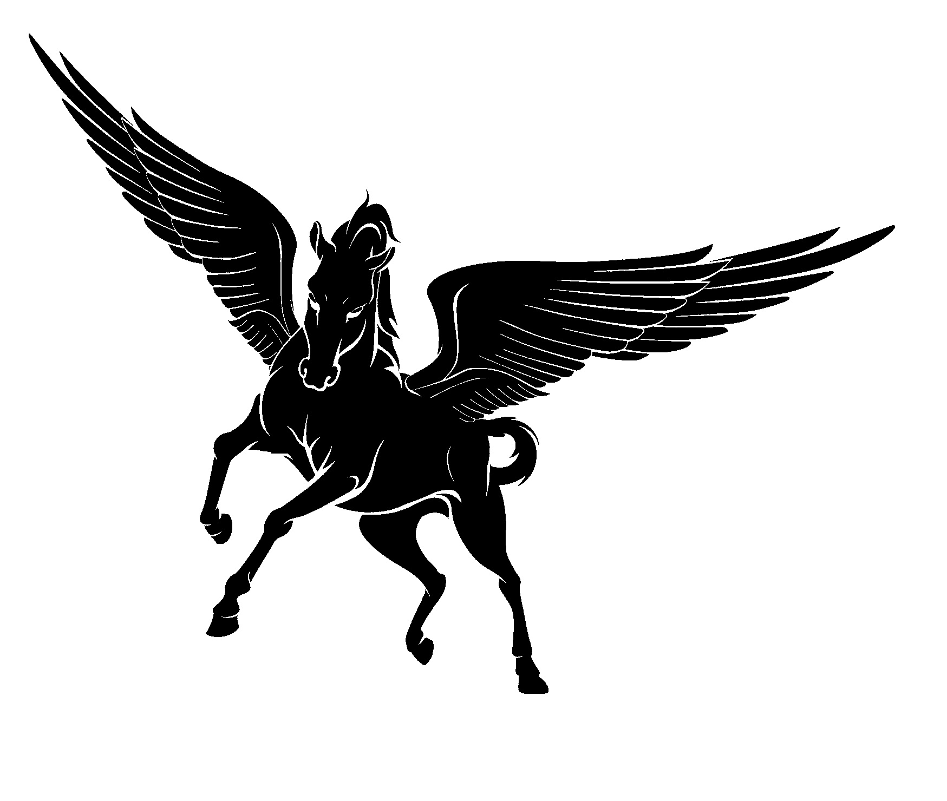Pegasus Aviation Service, LLC | www.PegasusAviation.NET  Info@PegasusAviation.NET  1-800-710-9144

Contact us today about an introductory flight. Intro flights begin at $75.00 for a ½ hour flight in an airplane.  Aircraft and instructors are ready to help you reach your goals. No matter what stage of your training, Pegasus Aviation Service, LLC can help you complete your License.  We offer traditional Pay as you go or accelerated training solutions.  Our instructors have over 50 years combined experience. | 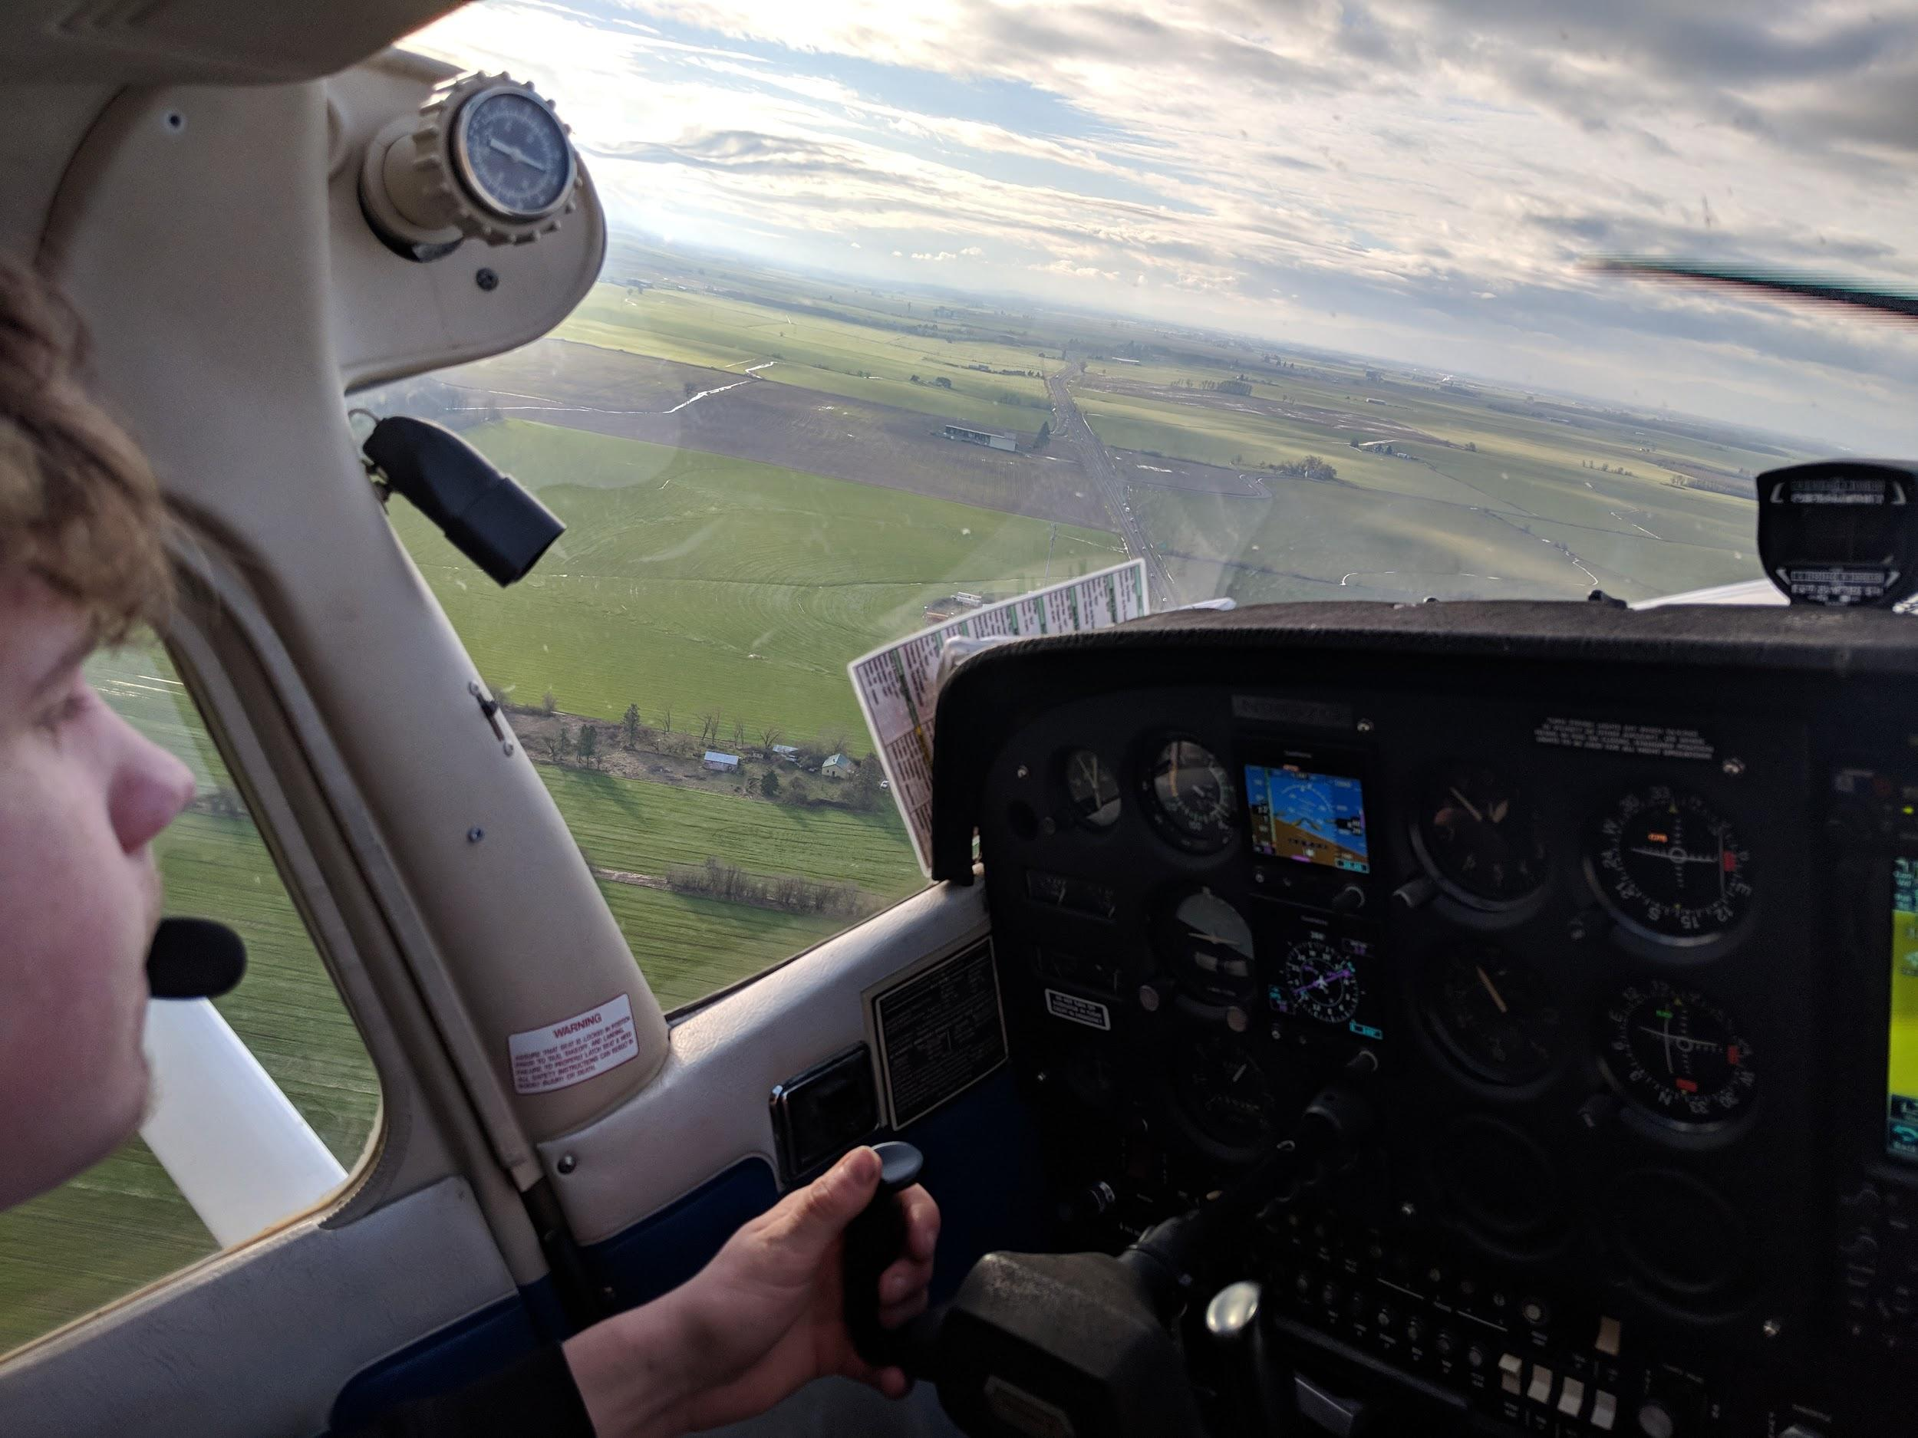  Fly in this Technically Advanced Trainer.

The private pilot rating requires:  40 Hours Total Flight/Training Time which includes:  20 Hours of Dual Flight Instruction  3 Hours of Dual Night Flight  3 Hours of Instrument Training  10 Hours of Solo Flight  5 Hours of Cross Country Flight  10 Hours of Ground Instruction  Additional costs include the instructor, books, supplies, knowledge exam, and check-ride.  Rental Aircraft | Training Costs  These costs are bare minimum, it is usually more, it really all depends on the student.
  Ce 172M - TAA  Ce 172M  Ce310Q Multi Engine | $160 ph  $140 ph  $295 ph
  Cessna 172M  FAA written exam  FAA practical exam  FAA medical exam  40 hours @ $130 ph  20 hours flight instruction $45 ph  10 hours ground $45 ph  Books from FAA are free.  Headset, books, etc  Total Base cost  Most students take an additional 20 hours in the airplane more than the minimum which adds another approx $2600.00 | 140-160  $160  $700  $120  $5200  $900  $450  $500  $500  $8,530  $11,130

